

Design Specification

Domino-INT003 WMS-INV Inventory Transactions/Adjustment (On Hand Stock Recon)
5th June 2024, Version 1b.
Copyright © 2024, Oracle and/or its affiliates
Confidential – Oracle Restricted

Document Control

Change History
Date | Author | Version | Description
01-Jul-2024 | Amit Sharma | 1a | Initial Version
12-Jul-2024 | Sudhakar V P / Meera Ganapathy | 1b | Cross Functional updated version
25-07-2024 | Shireesha Veeramalla | 1c | Technical details

Reviewed By
Date | reviewer | role
26-07-2024 | Rakesh Kumar Mishra | Technical Lead

Table of contents
Document Control 3
Change History 3
Reviewed By 3
Introduction 6
Purpose 6
Scope 6
Functional Overview 6
Business Objectives 6
Process Overview 8
Mapping 13
Pre-Conditions 13
Risk Matrix 14
Other Integrations Design Dependency 14
Frequency 15
Open Items 15
Business Use Case: 15
Technical Overview 15
Scope 15
Glossary 16
Document References 16
Sample Data & Mapping Template 16
Frequency 16
Assumptions 16
High Level Approach 16
Pre-Requisites 17
Integration Analysis - XxInvOnHandSnapshotWmsToErp 17
Integration Components 17
Required Connections 17
Integration Outline 17
Main Code Flow Snippet 19
Global Fault 24
Migration Steps 26
Unit Testing 26
Open and Closed Issues 27

Introduction

Purpose
The objective of this document is to provide a Design Specification for Inventory transaction and inventory reconciliation between WMS and Fusion cloud.
Also, to provide the necessary information with enough detail so that the Project team, have a clear understanding of the design and functional requirements.

Scope
This document specifies the business context, functional requirements, and details to integrate different inventory transactions happening in WMS Cloud (cycle count, sub inventory transfer, stock write off) and the inventory balance snapshot from WMS to Fusion cloud.
A warehouse management system (or WMS) is a software application designed to support warehouse or distribution center management and staff. They facilitate management of available resources to move and store materials into, within, and out of a warehouse, while supporting staff in material movement and storage.
Inventory Management Cloud supports a central integration framework across Oracle Procurement Cloud, Oracle Order Management Cloud, and Oracle Inventory Management based on web services to support the interactions between WMS and Fusion Cloud.

Functional Overview
Fusion Inventory Management supports a central integration framework for working with warehouse management systems (WMS). The inventory management suite of products includes Fusion Receiving, Fusion Inventory Management, and Fusion Shipping.
All the inventory adjustment transactions performed in WMS should be interfaced to Oracle inventory to update the on-hand quantities as well as track the transactions.
The Functional Specifications described here below refers to the integration scenario of inventory adjustment performed in WMS. The solution designed in this document is that allows to bring ‘adjusted’ stock information from WMS to SCM Cloud application. The solution design in this document will ultimately allow reflecting stock changes generated in WMS into the corresponding SCM sub inventories.
At the present status of analysis, for the inventory adjustment integration, Inventory History files are intended as scheduled maximum every 2 minutes to create or update Oracle SCM Cloud incrementally with adjustment details.
This integration between WMS Cloud and SCM Cloud has the purpose to cover the Inventory adjustments during the following transactions:
  - Internal Slot Moves (Sub-Inventory Transfer)
  - Scrap Inventory/Consume LPN (Miscellaneous Issue)
  - Cycle Count Adjustments (WMS Cycle Count Issue/ WMS Cycle Count Receipt)
  - Inventory Reconciliation

Business Objectives
When integrating Fusion Cloud with a warehouse management system (or WMS), All changes that occur within the fusion cloud must be integrated appropriately to keep the documents in sync in Oracle WMS Cloud.
The following figure illustrates how Inventory Management integrates with WMS systems. The Integration for Inventory Transactions from WMS to Fusion Inventory Management is used for this integration documents.

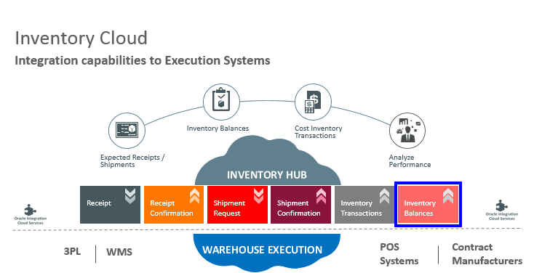

Process flow diagram
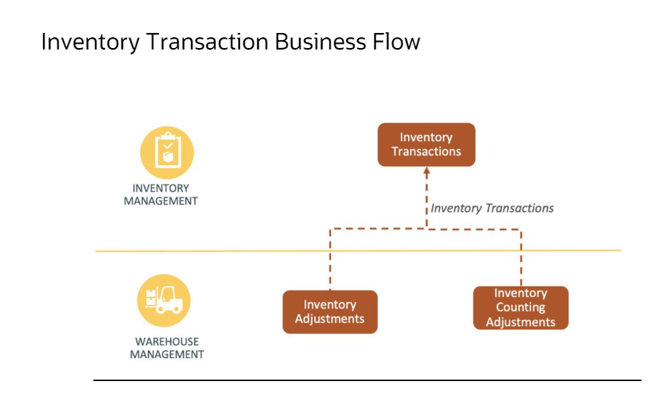
The above picture depicts the general steps in the Inventory Transaction business flow. The steps initiate in Warehouse Management Cloud (WMS). Once the transaction is completed in WMS, it will be sent to Fusion via OIC.

Process Overview
- Internal Slot Moves (Sub Inventory Transfer)
This section of the integration between WMS and SCM Cloud has the purpose to cover the Inventory adjustments when an inbound container (IBLPN) is moved within the warehouse. Based on the activity codes mentioned below, we need to update SCM Cloud accordingly with the quantity and serial number/lot number of inventories that was in WMS Cloud.

The following is a high-level view of the most relevant information to be considered:

  - Facility Code (Inventory Organization in SCM Cloud)
  - Activity codes: 22,23, 24,25 51,2,4,49,63,64
  - Item code
  - Original Quantity
  - Adjusted Quantity
  - Serial Number (for serial-controlled items)
  - Lot Number (for lot-controlled items)
  - Lock code value
  - Sequence Number of IHT Code

Process | SCM Cloud Impact | IHT Code from WMS Cloud
Move LPN from one location to other. | Inventory level will be adjusted based on info transmitted from WMS Cloud. | 24, 51, 22, 25, 51, 23, 63, 64, 24,2,4,49

For the internal LPN Movement in WMS Cloud the diagram to illustrate process is the same used for the container lock and unlock:
Process Flow:

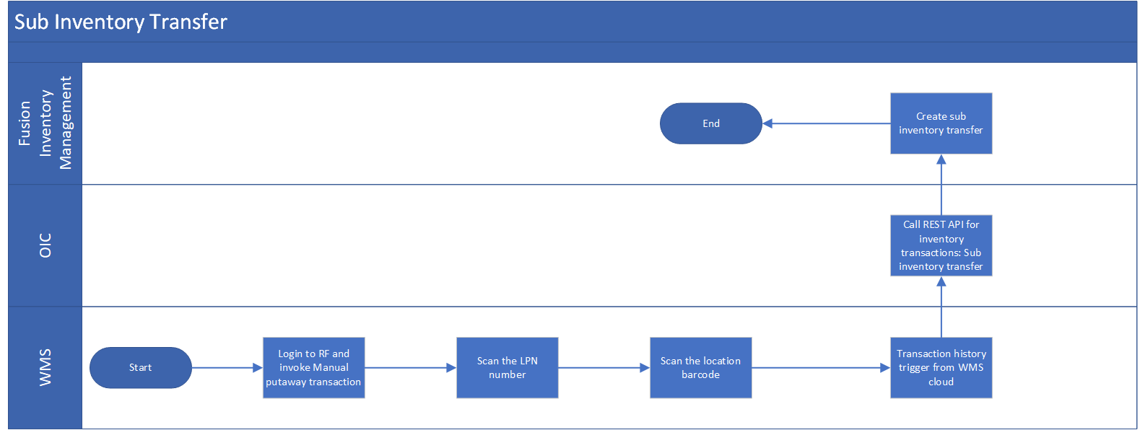

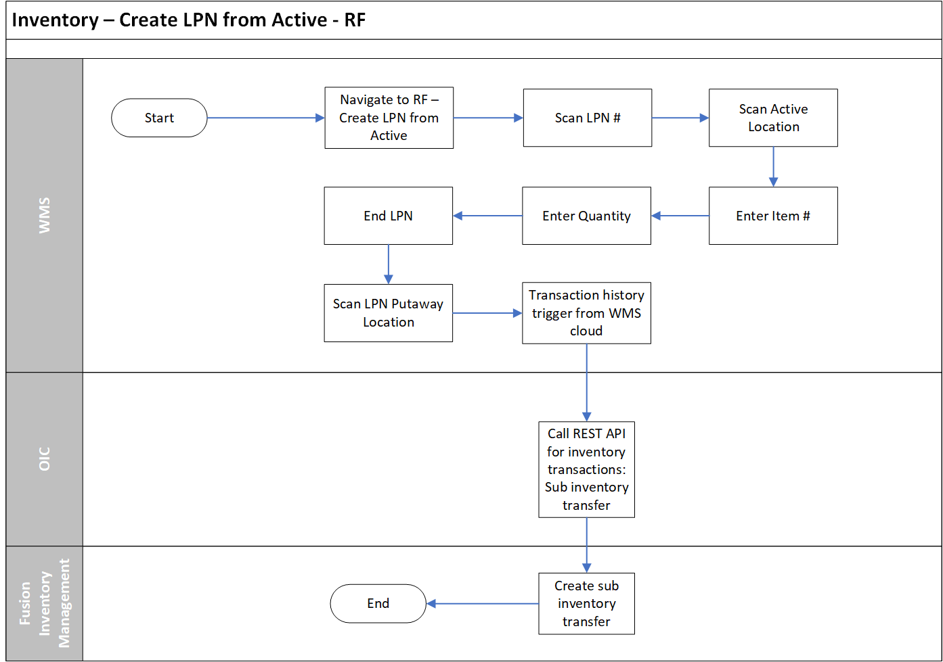

- Scrap LPN Process
This section of the integration between WMS and SCM Cloud has the purpose to cover the Inventory adjustments when an inbound container’s inventory is written off within the warehouse. Based on the activity codes mentioned below, we need to update SCM Cloud accordingly with the quantity and serial number of inventories that was in WMS Cloud.

The following is a high-level view of the most relevant information to be considered:

  - Facility Code (Inventory Organization in SCM Cloud)
  - Activity codes: 2
  - Item code
  - Original Quantity
  - Adjusted Quantity
  - Serial Number (for serial-controlled items)
  - Lot Number (for lot-controlled items)
  - Lock code value
  - Reason code value
  - Sequence Number of IHT Code

Process | SCM Cloud Impact | IHT Code from WMS Cloud
Consume LPN in WMS | Inventory level will be adjusted based on info transmitted from WMS Cloud. | 2

- Cycle Count Adjustment
In Fusion, the items will be classified under different count classes (ABC Classification) based on a certain criterion. The items would then be updated in WMS and the cycle count process for those classes will be carried out in WMS. The adjustments would then be posted to Fusion with the transaction type as WMS Cycle Count Receipt or WMS Cycle Count Issue and the transaction source type will be Inventory.
This section of the integration between WMS and Inventory Cloud has the purpose to cover the Inventory adjustments when Cycle count is performed in WMS. Cycle count can be performed for both Reserve and Active locations. Cycle count can be done at LPN level (CC Location LPN Scan-Scan the location and each LPN in the location) Or at LPN Detail level (CC Location Content- Scan the location and each LPN in the location, followed by the SKU quantity) or Cycle Count Active Location (Scan the location-Scan SKU-Scan Item-Enter Quantity-Scan serial/lot). Inventory history record will get created after performing Cycle count. Inventory history record will contain respective Inventory History Activity Codes with Original and Adjusted quantity.

If Adjusted quantity value is “+ve” then the adjustments will be posted to Fusion with the transaction type as WMS Cycle Count Receipt and the transaction source type will be Inventory.

If Adjusted quantity value is “-ve” then the adjustments will be posted to Fusion with the transaction type as WMS Cycle Count Issue and the transaction source type will be Inventory.

The following is a high-level view of the most relevant information to be considered:

  - Facility Code (Inventory Organization in Fusion Cloud)
  - Activity codes (40,41,53,19)
  - Item code
  - Original Quantity
  - Adjusted Quantity
  - Lot Number
  - Expiry Date
  - Serial Number
  - Lock code value
  - Sequence Number of IHT Code
  - Group Number

Process | SCM Cloud Impact | IHT Code from WMS Cloud
CC LPN Scan (Reserve Location)  -Ve Adjustment | Inventory level will be adjusted based on info transmitted from WMS Cloud. | 41,51,40
CC LPN Scan (Reserve Location) +Ve Adjustment | Inventory level will be adjusted based on info transmitted from WMS Cloud. | 41,51.39
CC LPN Detail Scan (Reserve Location) -Ve Adjustment | Inventory level will be adjusted based on info transmitted from WMS Cloud. | 41,51,40,53
CC LPN Detail Scan (Reserve Location) +Ve Adjustment | Inventory level will be adjusted based on info transmitted from WMS Cloud. | 41,51,39,53
CC Active Location | Inventory level will be adjusted based on info transmitted from WMS Cloud. | 19

Process Flow:
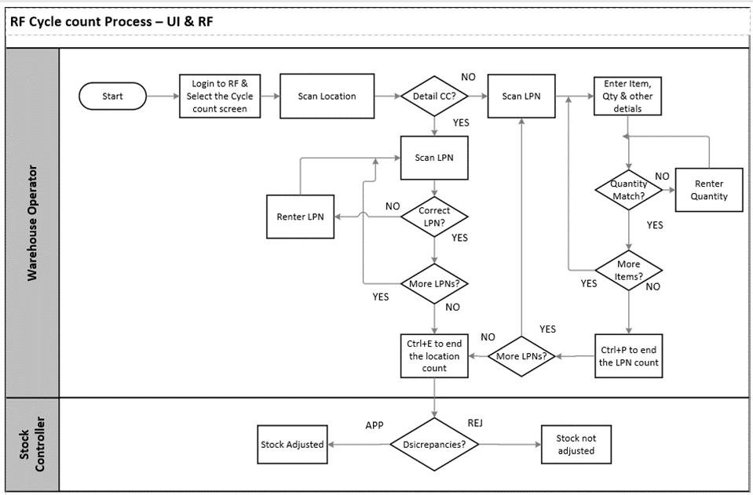

- Inventory Reconciliation from WMS to Fusion
The business objective is to create a visibility of both WMS and Fusion balances for comparison, hence enabling users to resolve any processing exceptions.

Any adjustment required, will be done manually (i.e.: there will be no ‘Force balances’).
Steps to execute this process:
- In Fusion, Run Purge Inventory Balance Messages Process
- Ensure No Errors in ‘Inventory Transactions’ and ‘Shipment and Receipts
- In WMS, Run WMS based reports (snapshot view of all facilities/inventory organizations) at silent hours i.e. after facility working hours.
- In Fusion, Run Manage Inventory Balances Process
- In WMS, Run ‘WMS to Fusion Reconciliation Discrepancy Report’ to view the organizations where discrepancies are reported comparing between Fusion and WMS.
  - Parameters to execute this report:
    - Business Unit
    - Source
  - Report displays below values:
    - In case of Error:
      - Organization Code
      - Organization Name
      - Source
      - Sub inventory
      - Lot or Serial Controlled
      - Item Number
      - New On-Hand Quantity
      - Error Message
    - Pending Approvals:
      - Organization Code
      - Organization Name
      - Source
      - Item Number
      - Lot or Serial Number
      - Sub inventory
      - Locator
      - On Hand Quantity
      - On Hand Quantity UOM
      - New On Hand Quantity
      - New On Hand Quantity UOM
      - Adjustment Quantity
      - Adjustment Quantity UOM
      - Adjustment Percentage
      - Adjustment Value Currency
      - Adjustment Value
      - Creation Date
      - WMS Extraction Date
- In Fusion, Navigate to ‘Manage Inventory Balances Messages in Spreadsheet’ – ADFdi spreadsheet
  - Review the Errors and Correct, as required

The inventory balances integration enables you to:
- Use the Inventory Balance Transactions service to post inventory balance messages from an WMS system.
- Enable users to resolve any processing exceptions and.
- Purge inventory balance messages periodically.

Use the following processes and task to interface with external systems to improve tracking and visibility across your supply chain, including partners:
- Manage Inventory Balances Processes and.
- Purge Inventory Balance Messages Process.

Manage Inventory Balances Process
This ESS Job process processes the imported inventory balance messages in the interface tables.
Purge Inventory Balance Messages Process
Use this ESS Job process to purge the historical balance inventory messages collected over time in the interface tables. Using the processing status parameter, you can purge error, successful, or all messages between a date range.
By integrating Fusion Inventory Cloud to the WMS System, which will help both the WMS system and Fusion Inventory in sync in terms of Inventory balances.

Mapping

Pre-Conditions
- The Fusion Inventory Organization structure should be mapped with WMS Inventory Organization structure. i.e., Inventory organization and Sub-inventory of Fusion should be mapped with WMS.
- Items should be active and in sync in Fusion Inventory and WMS.
- UOMs should be active and in sync in Fusion Inventory.
- On Hand / Stock should be in sync between WMS and Fusion in the corresponding Inventory Org / SubInventories / Serial / Lot
- Following Transaction Types should be available in Fusion:
  - WMS Cycle Count Receipt
  - WMS Cycle Count Issue
- There should not be any stuck transaction in WMS, OIC and Fusion Interface. If there is any stuck transaction, then need to be cleared.

Risk Matrix
Risk | Impact  (1 to 5) | Probability  (1 to 5) | Mitigation

Other Integrations Design Dependency
Name | Dependency | comments
WMS Items (INT001)
INV WMS Receipt Advice -PO (Except Cancellation process) (INT004)
INV WMS Receipt Advice - ASN (Supplier portal) ( Except - ASN Attachments and Cancellation) (INT034)
INV WMS Receipt Advice -RMA (Sales Order) (INT005)
WMS INV Receipt Confirmation (PO & RMA) (INT006)
INV WMS Shipment Requests (ship set + delivery ID) (INT007)
WMS INV Shipment Confirmation (SO)
& Transfer Order (INT008)
WMS INV Receipt Corrections (INT037)
WMS-ASN Creation for Transfer Order (INT045)
WMS INV Transfer Order Receipt (INT043)
WMS- ASN serial attachment modification (INT044)
INV WMS Transfer Order Creation (delivery ID) (INT042)
Min Max Replenishment - Movement Request (INT031)
Min-Max Pick Confirmation response (INT032)
WMS INV PO Returns (RTV Integration) (INT028)
QC Integration (INT040)
Create RTV Stock in WMS (INT047)
INV WMS FG Creation (Composite Create LPN) (INT041)

Frequency
Responsiveness | Frequency | Data volume
 | Schedule job for inventory transactions scheduled to run in WMS every 2 minutes
 | Inventory Reconciliation reports scheduled to run <Check with Domino on the frequency>

Open Items
This section is used to summarize any open items related to the design.
No. | open item | data required | status | impact if not closed
001

Business Use Case:
- Perform sub inventory transfer from one sub inventory to another.
- Write off stock from WMS using Consume LPN transaction for non-inventory item.
- Write off stock from WMS using Consume LPN transaction for serial-controlled item.
- Write off stock from WMS using Consume LPN transaction for lot-controlled item.
- Perform cycle count of a reserve location at LPN level in WMS.
- Perform cycle count of a reserve location at LPN detail level in WMS (for serial-controlled item)
- Perform cycle count of a reserve location at LPN detail level in WMS (for lot-controlled item)
- Perform cycle count of a reserve location at LPN detail level in WMS (for non-inventory item)
- Perform cycle count of an active location at LPN detail level in WMS (for lot-controlled item)
- Perform cycle count of an active location at LPN detail level in WMS (for serial-controlled item)
- Perform cycle count of an active location at LPN detail level in WMS (for non-inventory item)
- Run inventory reconciliation reports from WMS.
  - End of Each Day take the snapshot of inventory balances.
  - Extract inventory balances from WMS
  - Confirm that the inventory balances are processed and in sync with WMS system.

Technical Overview

Scope
The objective of this document is to provide Domino Printing with a Technical Specification of Inbound Integration for Inventory Transactions/Adjustments from WMS to Fusion.

Glossary
Annotation | Definition
ERP | Enterprise Resource Planning
SCM | Supply Chain Management
OIC | Oracle integration cloud
API | Application Programming Interface
SaaS | Software as a service
PaaS | Platform as a Service
BI Publisher | Business Intelligence Publisher
UCM | Universal Content Management
WMS | Warehouse Management System
ESS | Oracle Enterprise Scheduler
REST | Representational State Transfer
XML | Extensible Markup Language
XSD | XML Schema Definition
URL | Uniform Resource Locator
CSV | Comma-Separated Values
ICS | Oracle Integration Cloud Service
HTTP | Hypertext Transfer Protocol

Document References
Ref No | Name | File location

Sample Data & Mapping Template

Frequency
TBD

Assumptions
- The Fusion Inventory Organization structure should be mapped with WMS Inventory Organization structure. i.e. Inventory organization and Sub-inventory of Fusion should be mapped with WMS.
- Items should be active and in sync in Fusion Inventory and WMS.
- UOMs should be active and in sync in Fusion Inventory.
- There should not be any stuck transaction in WMS, OIC and Fusion Interface. If there is any stuck transaction then need to be cleared.

High Level Approach
Oracle WMS Cloud generates web report for Inventory balances and loads the source files at SFTP. OIC Scheduled Integration picks those files and transforms to FBDI format and loads the file for inventory balances in Oracle SCM Cloud using an ESS job.
- ERP Adapter is used to upload file to the UCM account scm/inventoryBalanceMessage/import using the ERPIntegrationService- importBulkData operation.
- Manage Inventory Balances Process ESS job is executed to load data in interface tables.

Pre-Requisites
- Send Email Integration “XxCommonNotificationHandler” should be deployed in the OIC.
- Lookup “XXDominoCommonLookup” should be present with all the required details regarding success/error email notify flag, success and error notify ToEmail Address in OIC.
- Lookup “XxDominoConstantLookup” should be present with all the required details regarding success and error notify From Email Address in OIC.

Integration Analysis - XxInvOnHandSnapshotWmsToErp
This Integration component is responsible to import inventory balances extracted from from Oracle WMS to Oracle ERP through FBDI file.

Integration Components
Below are the required components for this integration.

Integration Name | Integration Pattern | Package Name | Lookup Name
XxInvOnHandSnapshotWmsToErp | Scheduled Integration |  | XXDominoCommonLookup,  XxDominoConstantLookup,  LOOKUP_FUSION_INBOUND,  LOOKUP_Email_properties

Required Connections
Connection Name | Connection Type | Connection Role
XXDominoERPRestInvokeCon | REST | Trigger and invoke
XxDominoErpCloudConnection_WMSINT | Oracle ERP Cloud | Trigger and invoke
XxOicFileServerSftpConnection | FTP | Invoke

Integration Outline
Import Inventory Balances WMS-ERP
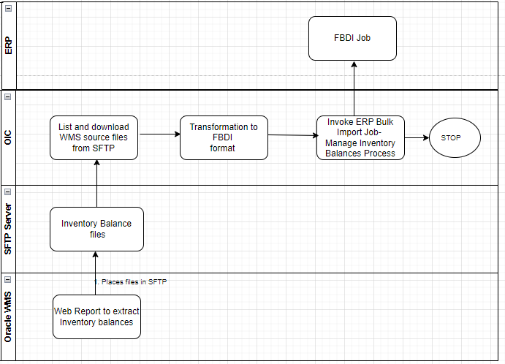
Figure 1: Architecture Diagram

The Following section explains the step – by- step process to import inventory balances from Oracle WMS to Oracle ERP through FBDI file:

Integration – XxInvOnHandSnapshotWmsToErp
- List WMS Report files from SFTP –
- When the file count is 3 -download lock code report, serial report , non serial report files from FTP.
- If the file count is not equal to 3 ,integration will send an email notification saying required files are not available for processing and moves the files to FTP Archive folder.
- WMS Serial report file processing(‘inventory_serial.csv')-check if the file has records to process.
- Incase of empty file do nothing.
- If WMSSerialrecords exists in the file -Stage write -If the sub inventory is blank fetch sub inventory for the corresponding items from lock code report file.
- Read the updated serial report file and check if facility code DE_M05 record available in the file.
- If DE_M05 Record exists Stage write – prepare the files in FBDI format for serial report file .( InvOnHandBalInterface and InvOnHandBalSerialInterface.csv ).(Group by itemcode , sub inventory , facility code )
- Stage read WMS Non Serial report file (inventory_nonserial.csv)
- Check if the file has records to process
- Incase of empty file do nothing.
- Stage write -If the sub inventory is blank fetch sub inventory for the corresponding items from WMS lock code report file (‘lpn_lock_code_report.csv’)
- Read the updated file -check if facility code DE_M05 record available in the file.
- Stage write – prepare the files in FBDI format for non serial report file.
- Append to 'InvOnHandBalInterface.csv' - IfOnly_DEM05_Exist
- InvOnHandBalLotInterface .csv – If WMSBatchRecordexsits and DEM05_Exists.
- we need to pass org id to the Purge ESS job which we are getting by invoking org API using organization name.
- Run purge program InvOnhandBalPurgeJob through ERP adapter using exportBulkData operation.
- Wait for the purge ESS job to get completed .
- Check If purge job status is successful
- otherwise send error email notification.
- If job is successful, Zip all the csv files which are in FBDI format (for each inventory org we need to prepare a separate zip file )
- This FBDI File is then uploaded to UCM through ERP adapter using importBulkData operation and ESS job Manage Inventory Balances Process to load data.
- Wait for the ess job to get completed .
- Move WMS source files to Archive folder once the ESS is succesful .

Main Code Flow Snippet

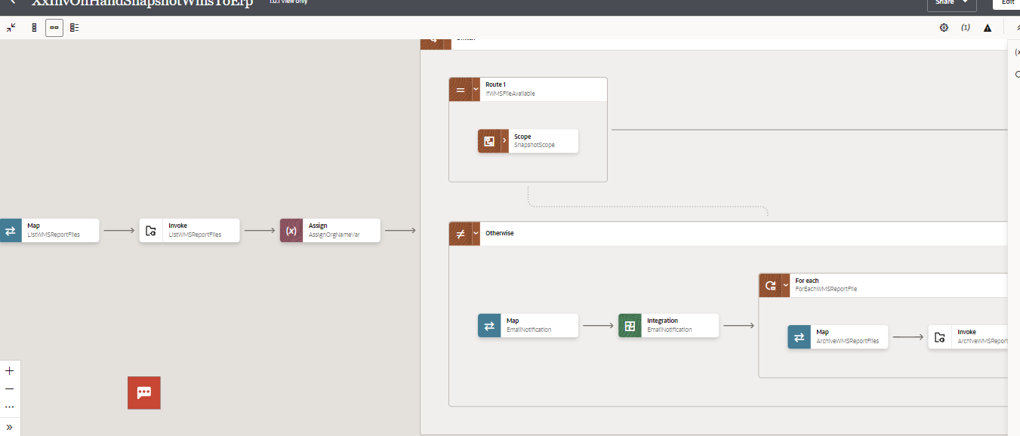
1b
1a
1

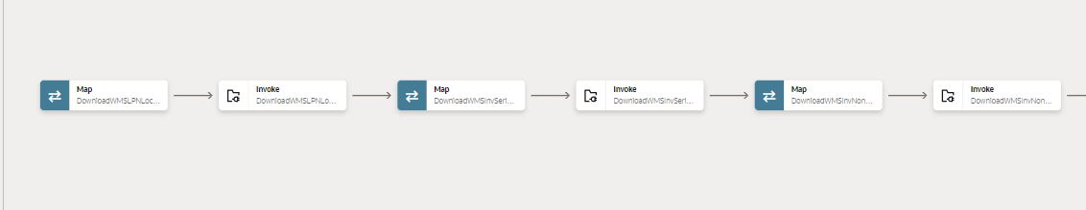
1a
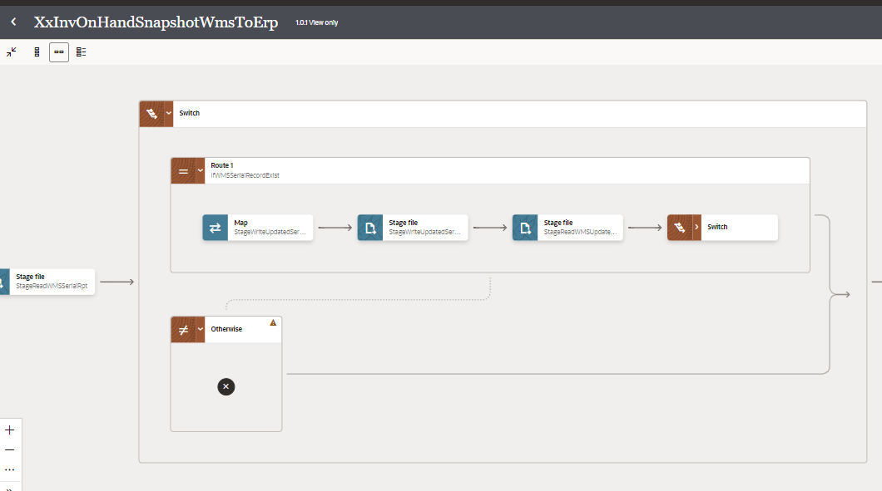
2a
2

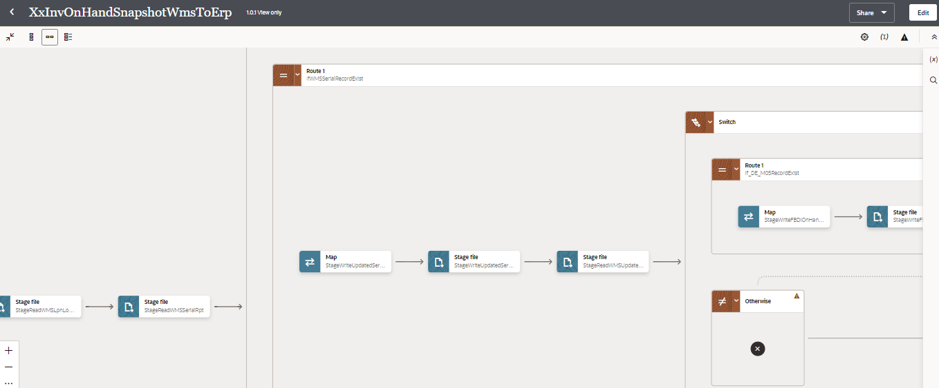
4
3

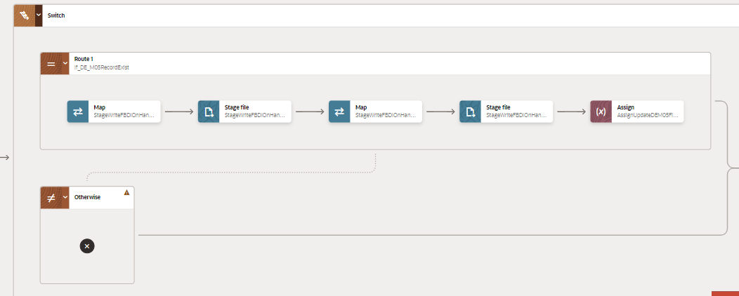
5

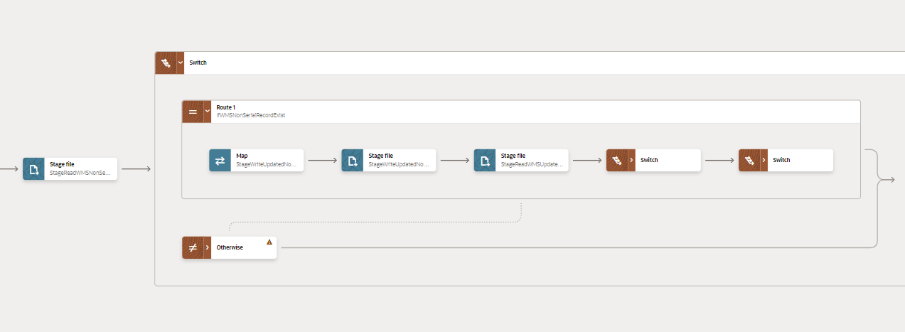
6a
6b
6

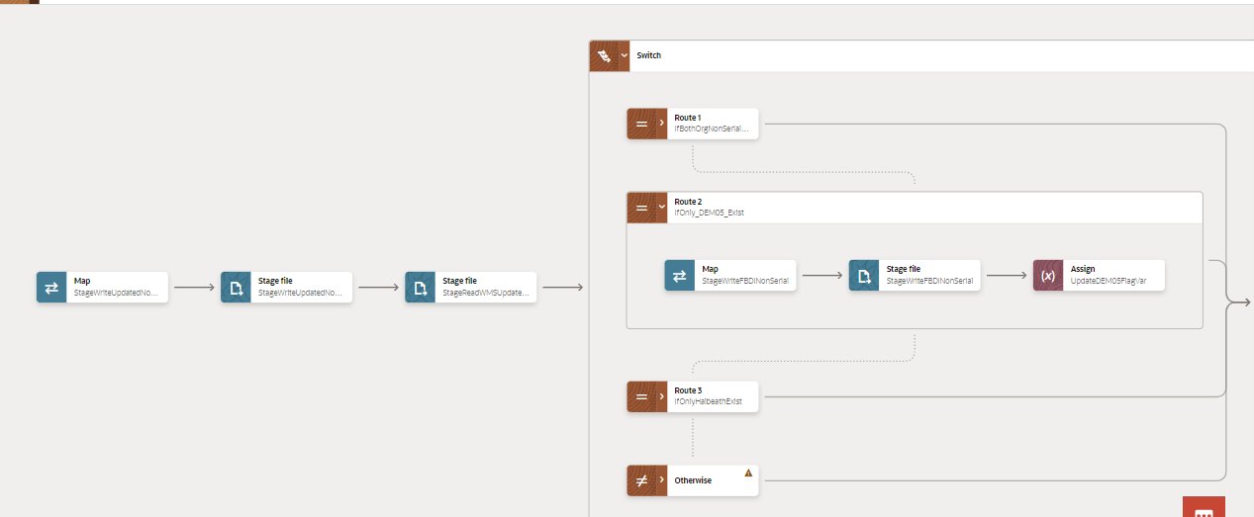
9a
8
7

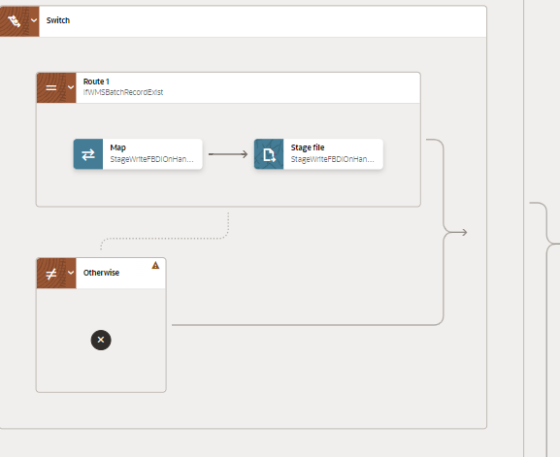
9b

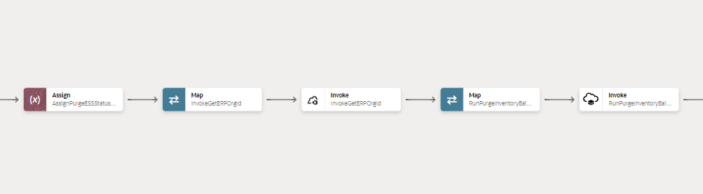
11
10
12
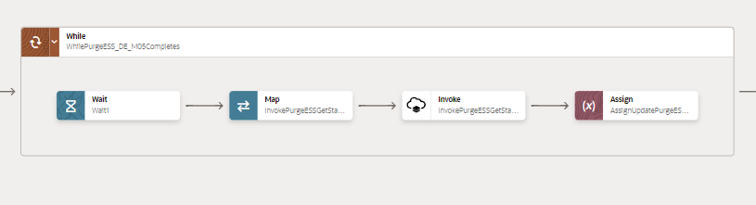

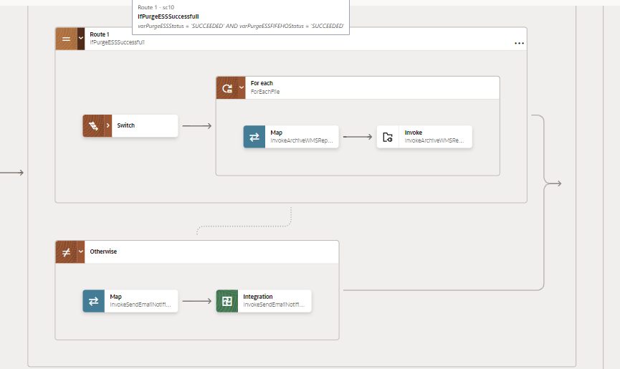
13a
13

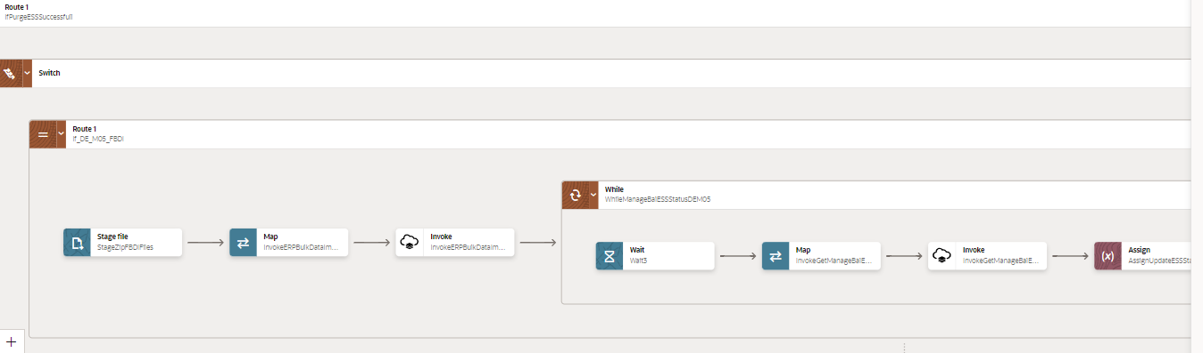
16
14
15

17
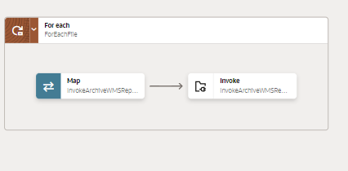

Global Fault
- The global fault handler is responsible for the whole execution scope and processes the exceptions occurred in the individual stages.
- Assign_GlobalVariable: The Global variable will be the Integration code which will be fetched from lookup “XXDominoCommonLookup” maintained in OIC. With reference of this lookup, all error variable values will fetch which are given as below:
Variable name | Data type | Value
IntegrationCode | String | dvm:lookupValue('XXDominoCommonLookup','IntegrationCode', ' ‘XXINVONHANDSNAPSHOTWMSTOERP', 'IntegrationCode', '')  IntegrationCode will be fetched from OIC lookup “XXDominoCommonLookup”, with reference to this lookup all other local variables will be fetched.  Value for IntegrationCode variable is Integration identifier.

- Assign_Errorvariables:
  - Using assign activity, variables will be declared to map the values required for invoking common error handler integration.
Variable | Values
IntegrationID | dvm:lookupValue('XXDominoCommonLookup','IntegrationCode', $IntegrationCode, 'RiceID', '')  This value will fetched from OIC lookup- XXDominoCommonLookup with reference of integration code value from Global variable.
ErrNotifyEmail | dvm:lookupValue('XXDominoCommonLookup','IntegrationCode', $IntegrationCode, 'FailureNotify', '')  This value will be fetched from OIC lookup XXDominoCommonLookup with reference of integration code value from Global variable. It will be failure notify email id.
EmailFrom | dvm:lookupValue('XxDominoConstantLookup', 'ID', 'FromEmailId', 'Value', '')  This value will be fetched from OIC constant lookup - XxDominoConstantLookup

- InvokeCommonErrorHandler:
  - The global fault handler will invoke the local integration “XxCommonNotificationHandler” which captures the error occurred at any step in overall integration flow and notify over email.
  - Using the map activity “Map to InvokeCommonErrorHandler”, process would map the below values required for XxCommonNotificationHandler.
Request Parameters | Values
IntegrationCode | $IntegrationCode
IntegrationID | $IntegationID
ErrorCode | $CurrentFaultObject/nsmpr0:APIInvocationError/nsmpr0:errorCode.
ErrMsg | $CurrentFaultObject/nsmpr0:APIInvocationError/nsmpr0:detail
EmailFrom | $EmailFrom
ErrNotifyEmail | $ErrNotifyEmail
EmailSub | concat($InstanceName,":","FYI",":","ERROR",":",$self/nsmpr1:metadata/nsmpr1:integration/nsmpr1:name,"(",$self/nsmpr1:metadata/nsmpr1:integration/nsmpr1:version,")",":",$self/nsmpr1:metadata/nsmpr1:runtime/nsmpr1:instanceId )
Logging | Y

Figure: Global Fault Code Snippet

Migration Steps
2
4

- Import “XXINVONHANDSNAPSHOTWMSTOERP_01.00.0001.iar” in OIC environment.
- Update the OIC Connections with Password, details as per the Environment.
- Validate the "XxCommonNotificationHandler", which is deployed in OIC. Update the values of Instance URL, Instance Name in Domino Constant lookup.
- Configure the Connection with Dev Instance URL, Instance Name (whenever updated) which is present in Domino Lookup maintained in OIC.
- Complete the OIC integration configuration and activate OIC service.

WMS sample Source Files
FBDI for Inventory Balances

Unit Testing
2
3

Please refer the attached file for the Unit Test cases performed for this integration.

Open and Closed Issues
This section is used to summarise any open and closed questions relating to Error Handler

ID | Topic | Description | Status | Owner
1
2.


Copyright © 2015, Oracle and/or its affiliates. All rights reserved. This document is provided for information purposes only and the contents hereof are subject to change without notice. This document is not warranted to be error-free, nor subject to any other warranties or conditions, whether expressed orally or implied in law, including implied warranties and conditions of merchantability or fitness for a particular purpose. We specifically disclaim any liability with respect to this document and no contractual obligations are formed either directly or indirectly by this document. This document may not be reproduced or transmitted in any form or by any means, electronic or mechanical, for any purpose, without our prior written permission.
Oracle and Java are registered trademarks of Oracle and/or its affiliates. Other names may be trademarks of their respective owners.
AMD, Opteron, the AMD logo, and the AMD Opteron logo are trademarks or registered trademarks of Advanced Micro Devices. Intel and Intel Xeon are trademarks or registered trademarks of Intel Corporation. All SPARC trademarks are used under license and are trademarks or registered trademarks of SPARC International, Inc. UNIX is a registered trademark licensed through X/Open Company, Ltd. 1212

Connect with us
blogs.oracle.com
facebook.com/oracle
twitter.com/oracle
oracle.com

